1. Crib, 같은 제조사지만 조금 더 오래된 모델입니다. 매트리스, 매트리스 커버 포함, $80
https://www.ikea.com/us/en/p/stuva-fritids-crib-with-drawers-light-blue-s79253184/

2. 기저귀 교환대, 패드, 커버, racks, $30
https://www.ikea.com/us/en/p/gulliver-changing-table-white-80307039/
https://www.ikea.com/us/en/p/skoetsam-changing-pad-white-70251797/
https://www.ikea.com/us/en/p/oensklig-racks-for-changing-table-set-of-4-white-30199283/

3. 운반용 카트, 베이지색, $10
https://www.ikea.com/us/en/p/raskog-utility-cart-white-20382932/

4. 바닥용 아기 매트리스 2개, $50 each
https://www.amazon.com/gp/product/B0058K5IIQ/ref=ppx_yo_dt_b_asin_title_o00_s00?ie=UTF8&psc=1

5. 분유포트, $20
https://www.amazon.com/gp/product/B073RCCNPD/ref=ppx_yo_dt_b_asin_title_o02_s00?ie=UTF8&psc=1

6. Jumperoo, $30
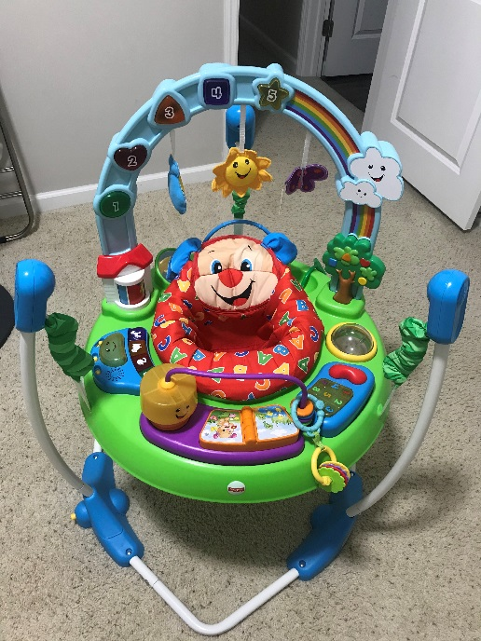
7. 아기 목욕용품, $20
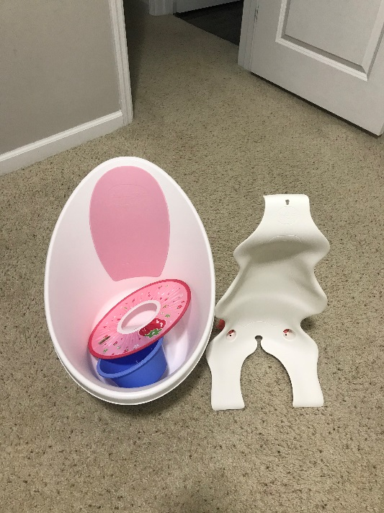
8. 수유 쿠션, 수유 시트, $20
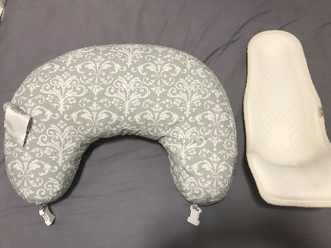
9. 선풍기, $10
https://www.costco.com/cascade-40-tower-fan-with-remote.product.100432740.html

10. Columbia, 여성용 스노우 부츠 (검정색), 겨울 슬리퍼 (베이지색) size 7, $15 and $15
https://www.amazon.com/Columbia-Womens-Aspen-Winter-Waterproof/dp/B01M7R3LLW/ref=cm_cr_arp_d_product_top?ie=UTF8
https://www.amazon.com/Columbia-Womens-Duchess-Suede-Slippers/dp/B07HHL57Y1?th=1&psc=1

11. 버너, 불판, $15
