◦ Shelves 1 ($30)
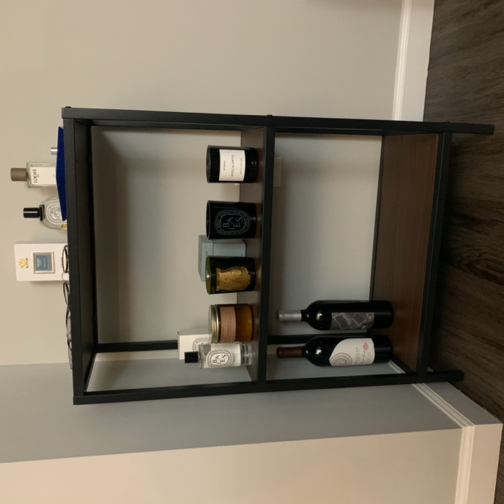

◦ Floor Lamp 1 ($15, include extra light bulbs)
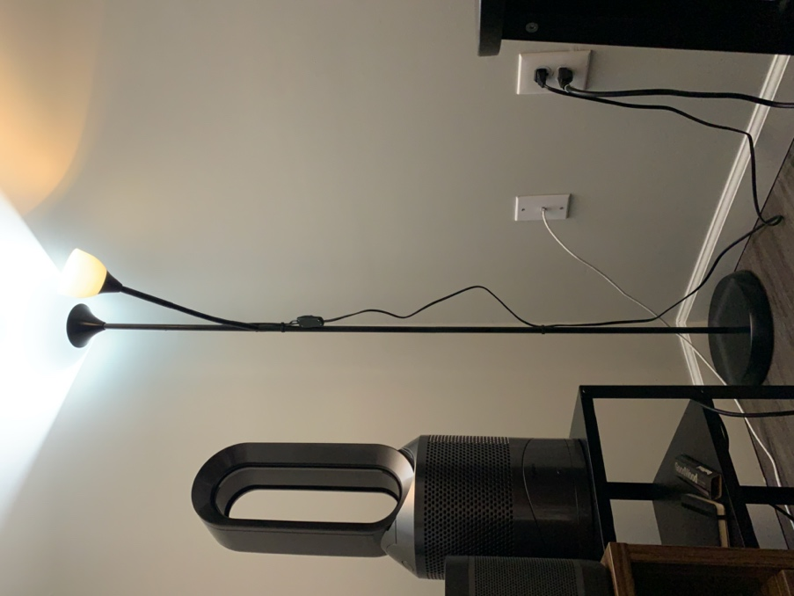

◦ Floor Lamp 2 ($35, include extra light bulb)
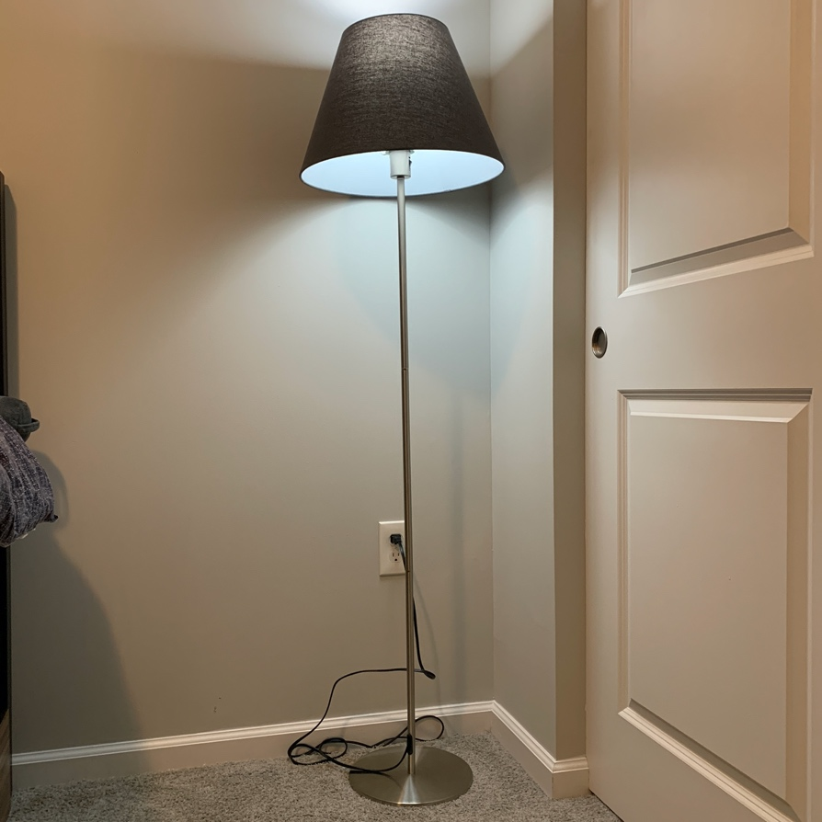

◦ Dyson Pure Hot + Cool. Purifier, fan, and heater ($450)
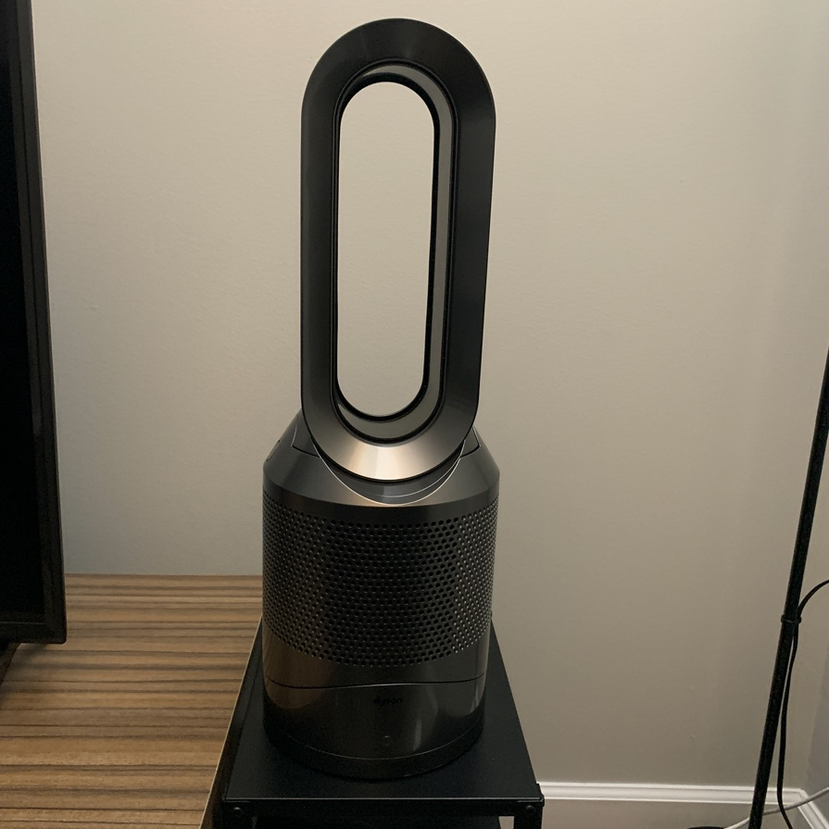
◦ Cordless Vacuum ($130)
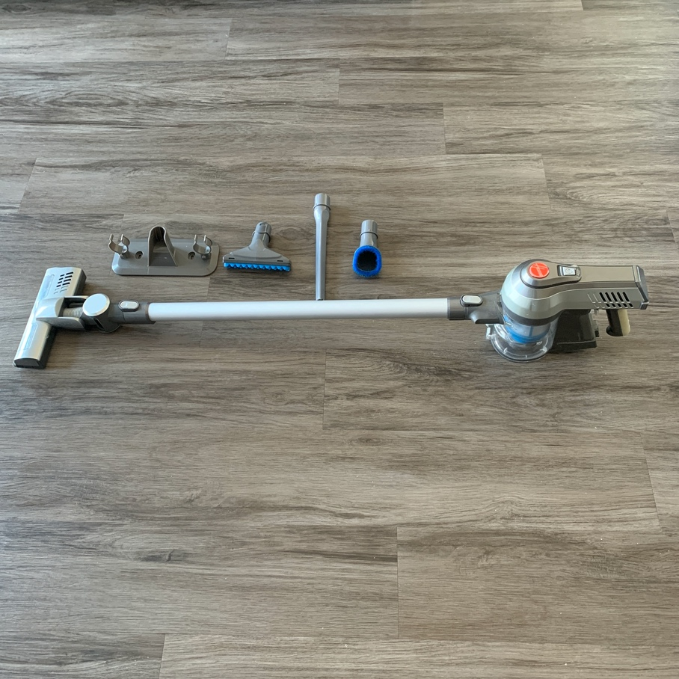

◦ Electric Kettle ($35)
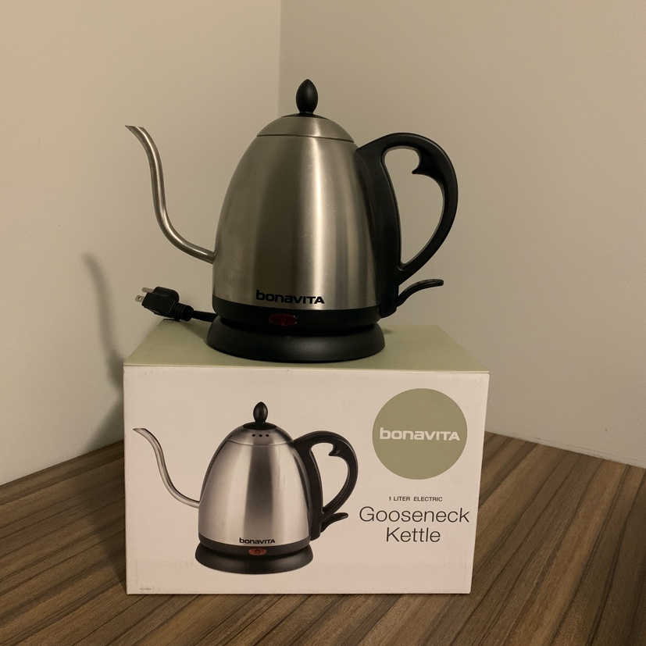

◦ Hair Dryer ($12)
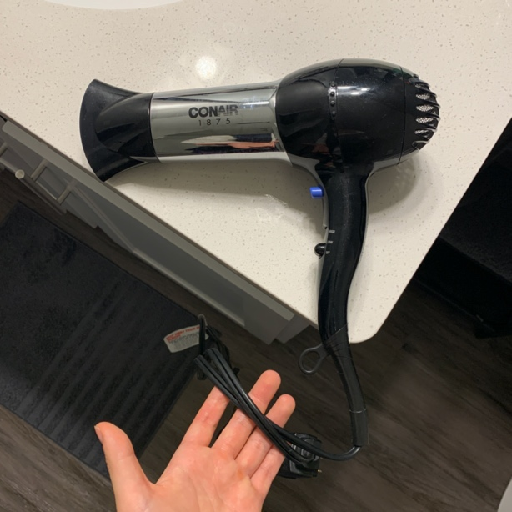

◦ Bar Stool ($8)
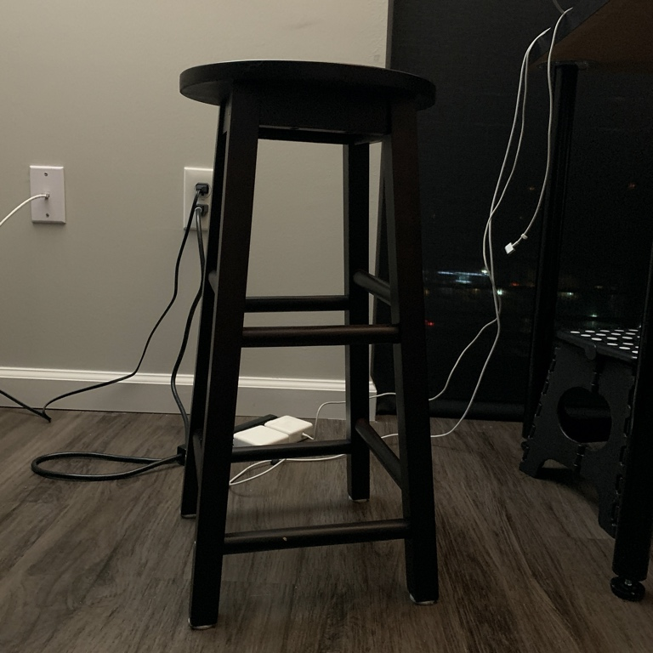

◦ Trash can ($10)
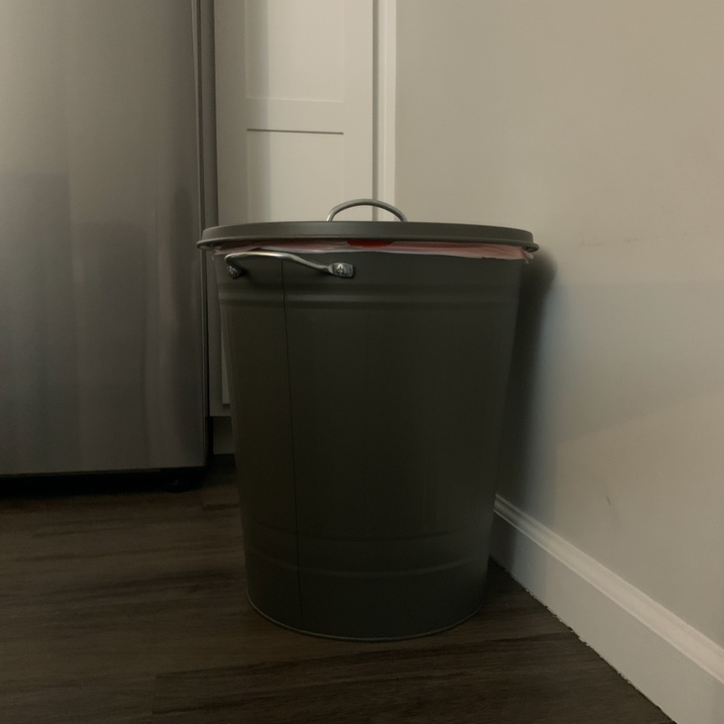

◦ Desk Lamp ($20)
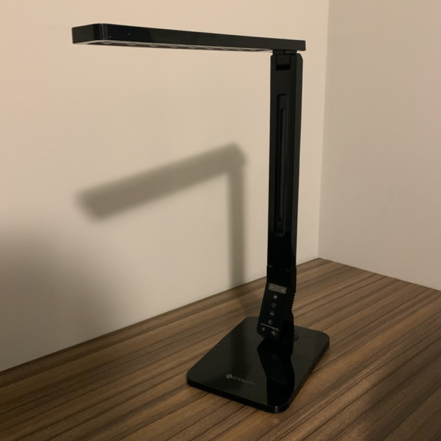

- Router ($40)
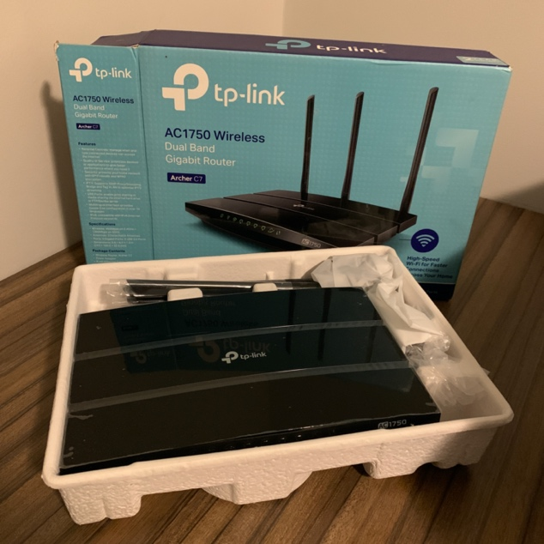

- Cushion *2 ($10 - price for two)
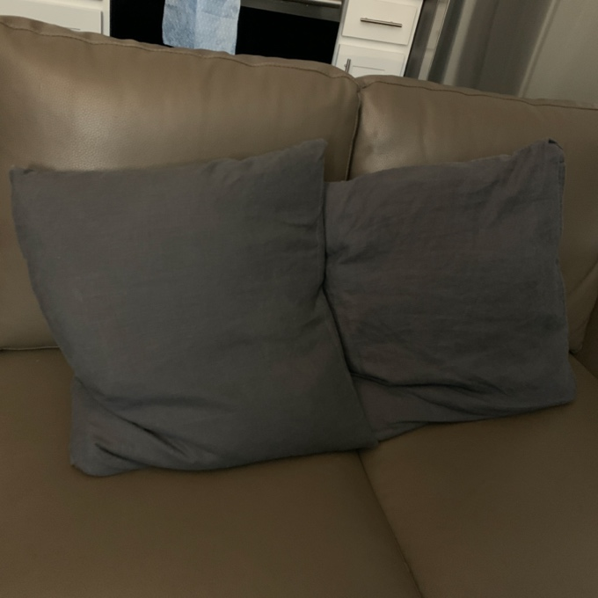

- Swiffer ($8)
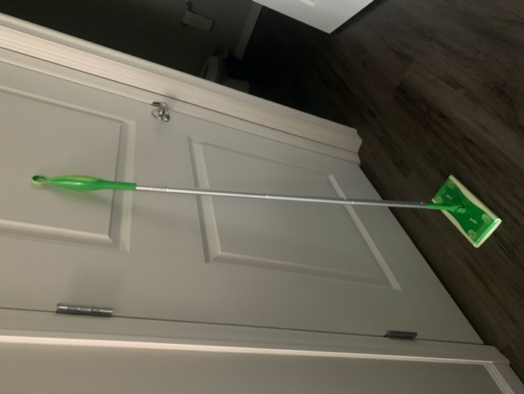
- Doormat ($10)
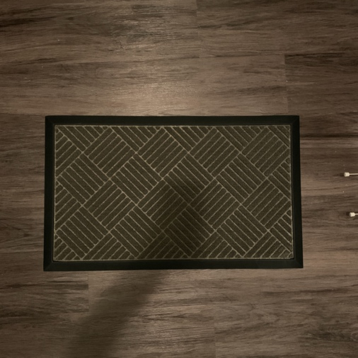

- Hot pad ($25)
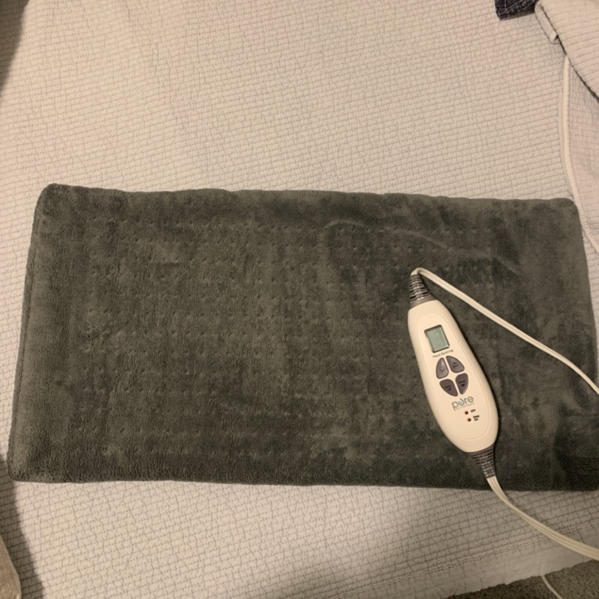

- Mattress cover & Mattress protector($30)
