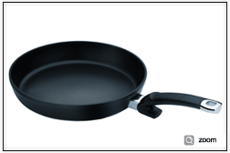 | Protect Alux Premium Frypan  Item Number Diameter  158 100 24 100 24cm / 9.5 in  158 100 28 100 28cm / 11.0 in
Ultimate Frying System Product Line
Crispy Steelux Premium Frypan
Item Number | Diameter
121 100 24 100 | 24 cm / 9.5 in
121 100 28 100 | 28 cm

