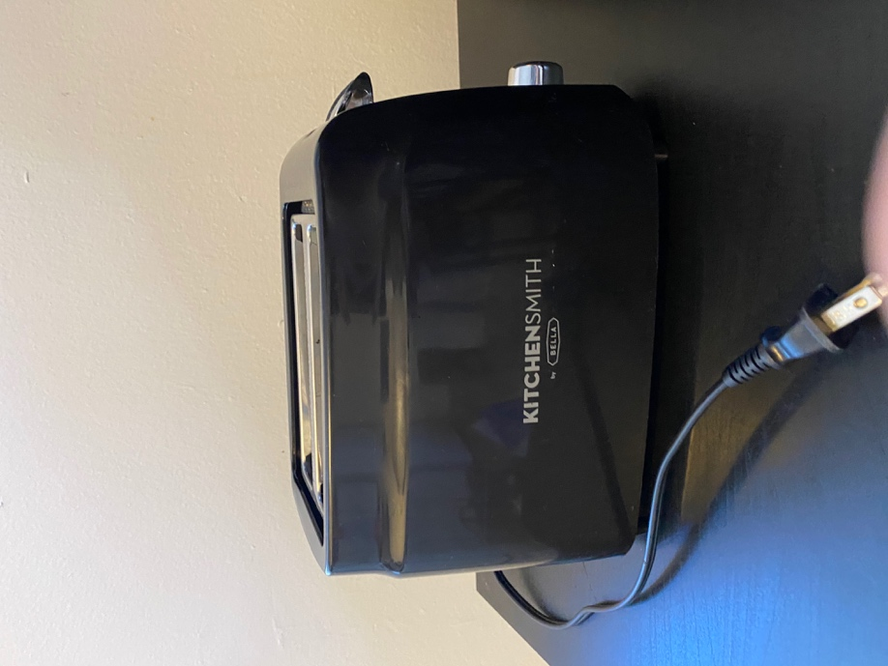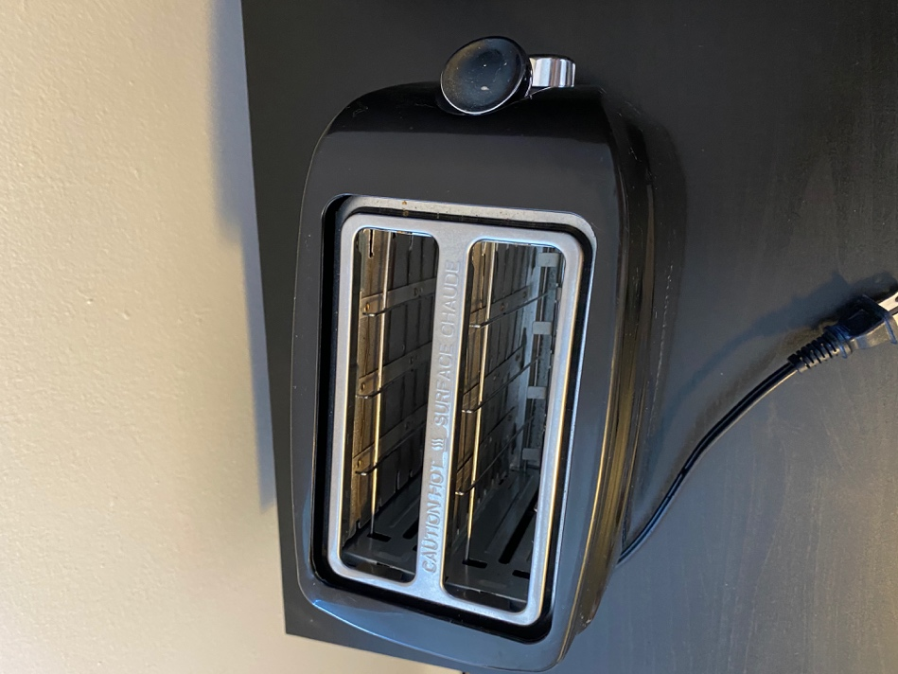 토스터 $5

노트북 거치대 $5

모니터 $10

신발장 $10 (두개로 나눠집니다)

[For Free]

- 30 x 3’8’’ x 26 ½’’

와인잔 x4 (두잔은 새것 입니다)