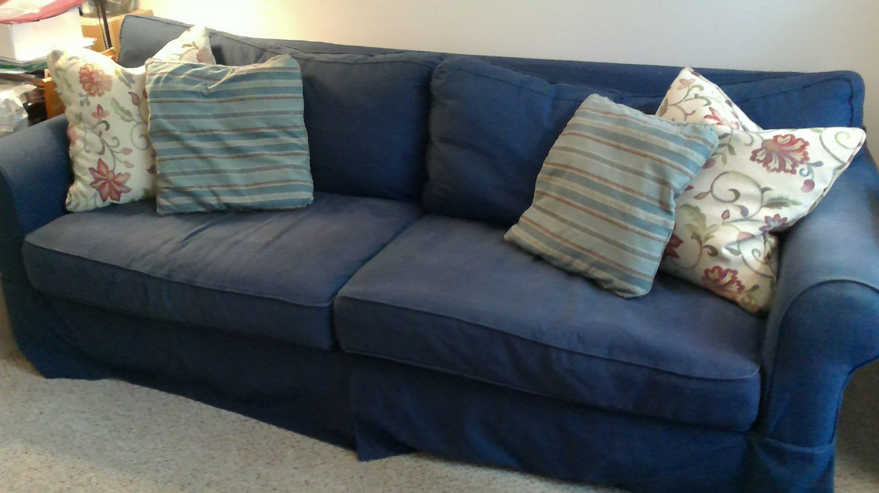
COUCH $200 (Originally $1500)

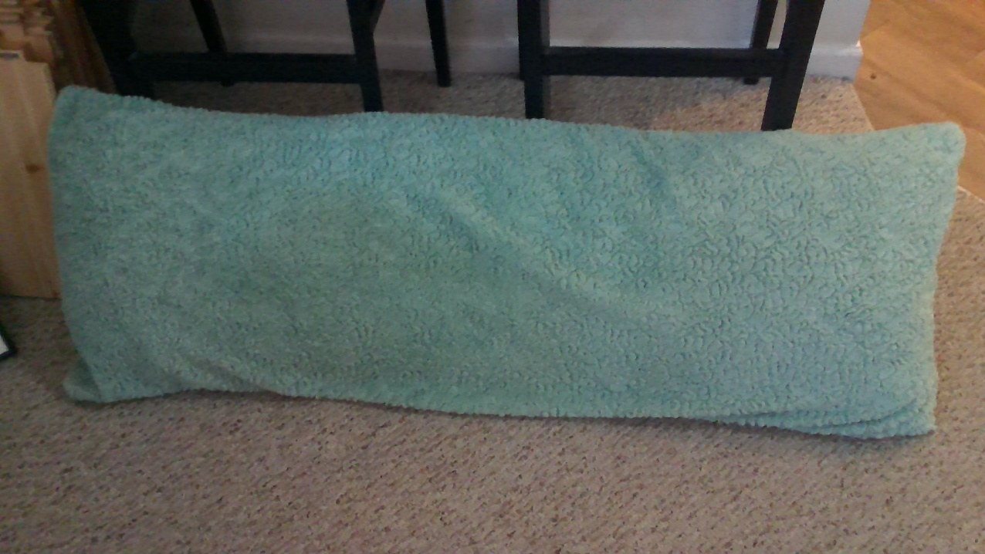
BODY PILLOW $ 5

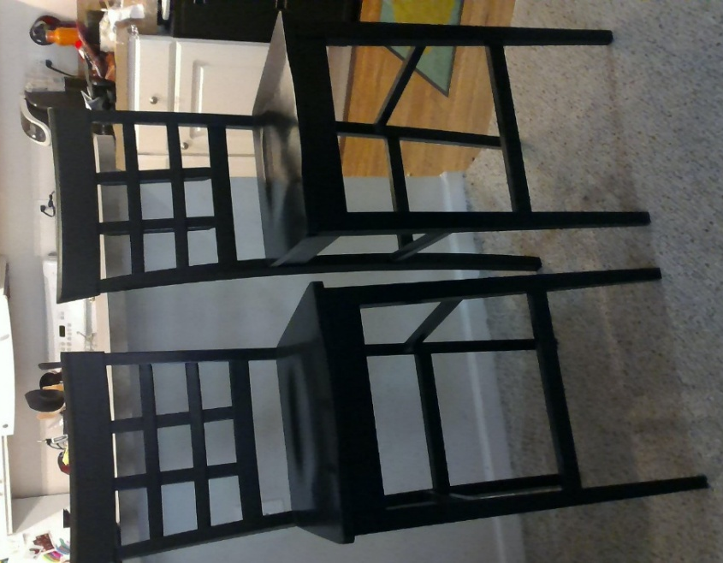

BAR STOOLS (set of 2) $60
(Originally $170)

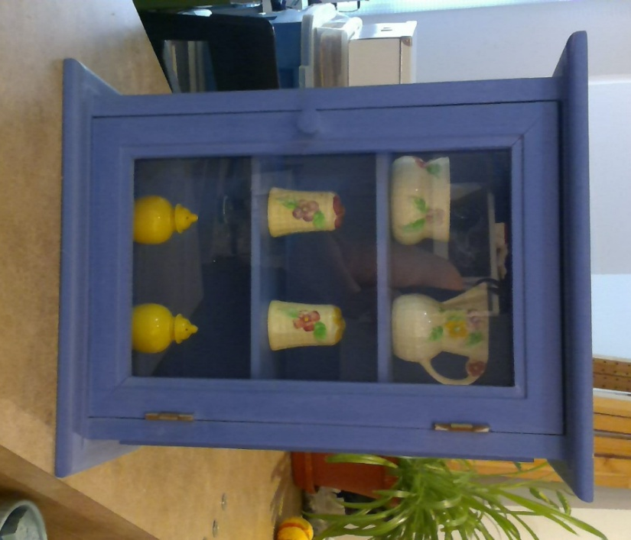

PERIWINKLE CABINET $15
(Pottery Barn)
* Stuff inside NOT included
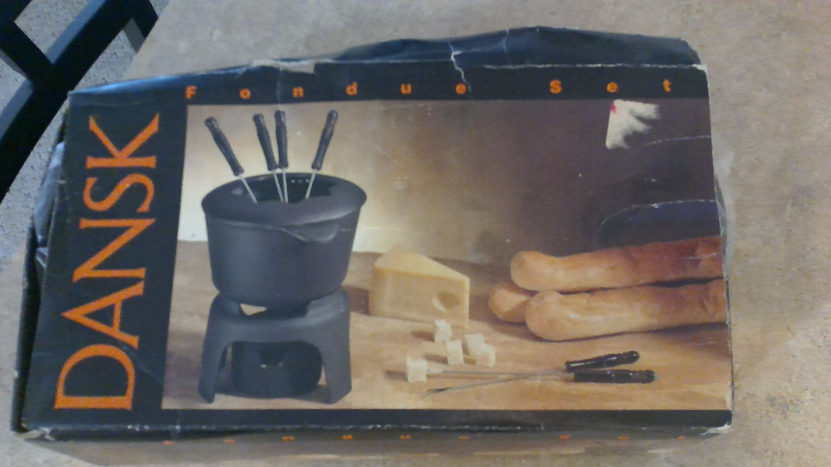
FONDUE POT $20 (Originally $80)
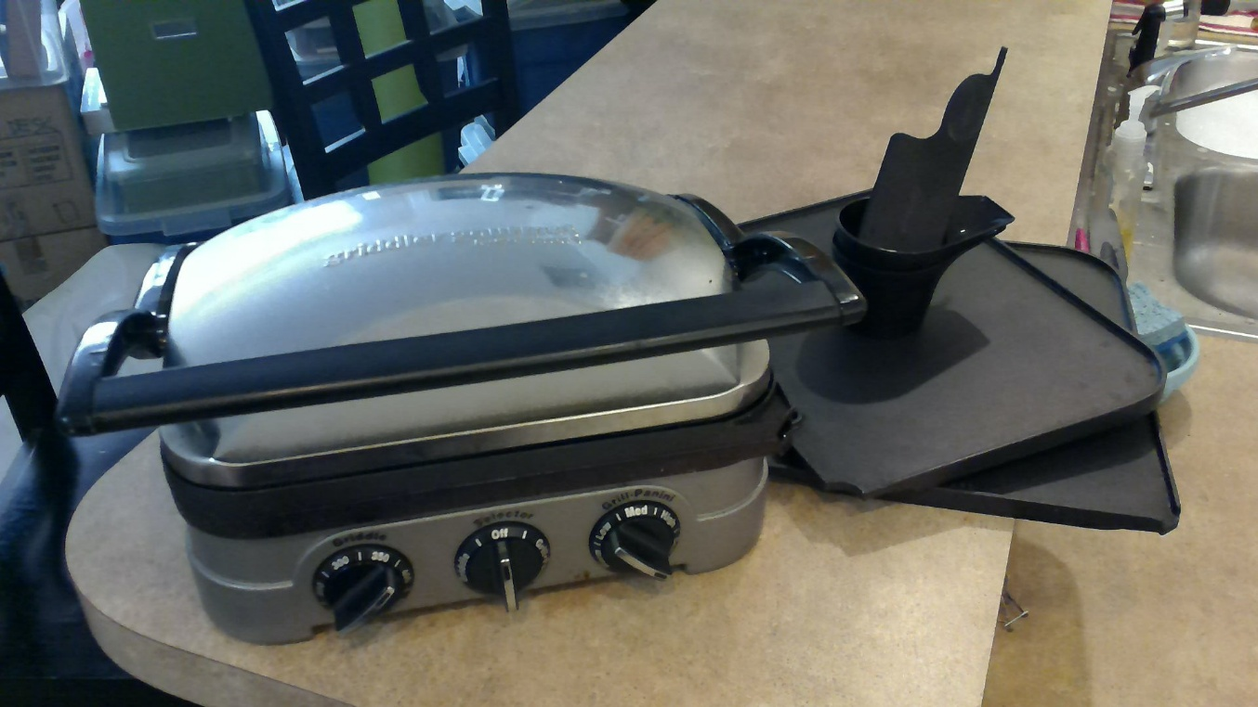
CUISINART GRIDLLER $10 (Originally $60)
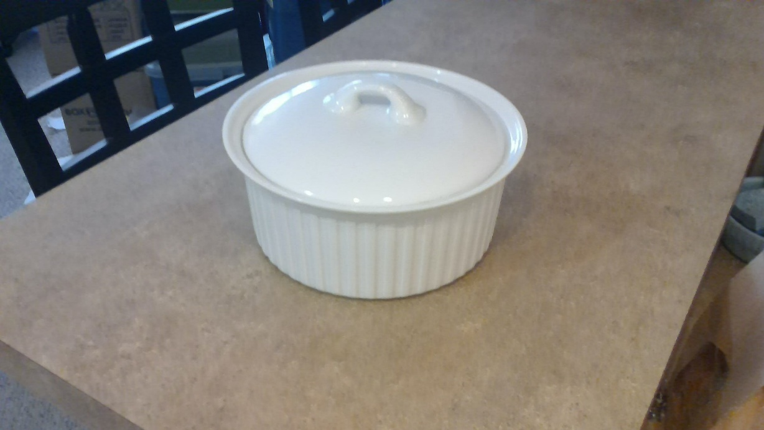
CASSEROLE DISH WITH LID $5

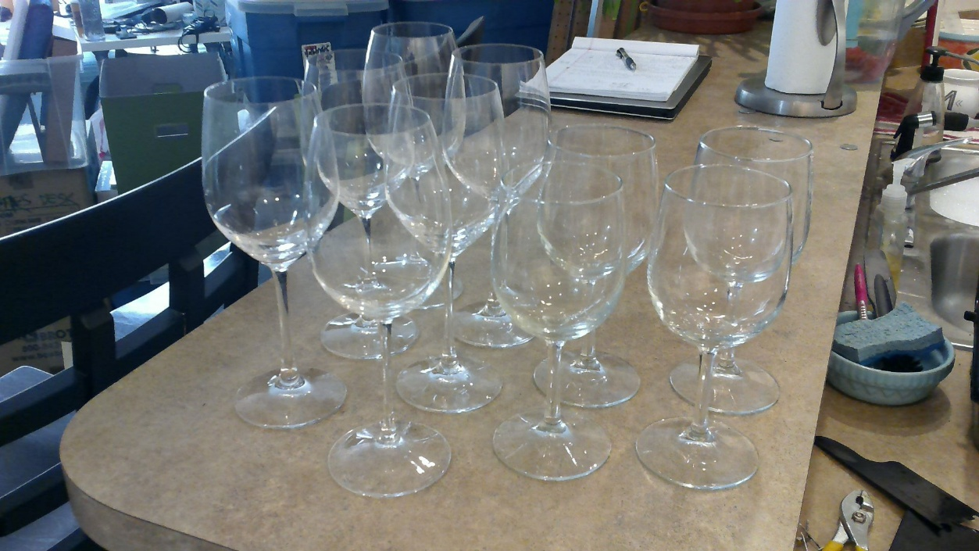
WINE GLASSES (SOLD AS A SET OF 10) $10

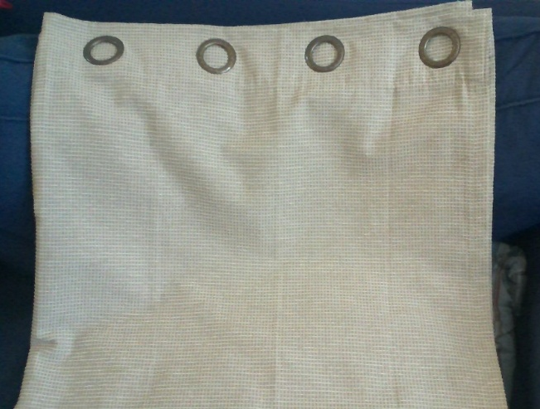
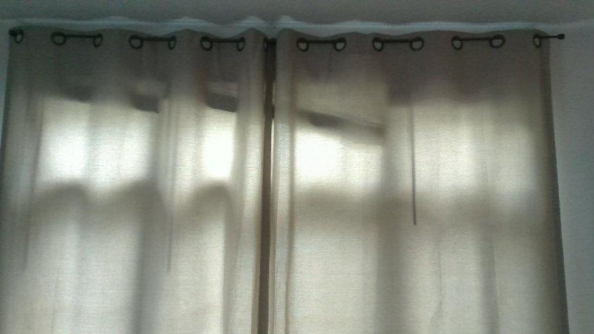

CURTAINS 95” PANELS COLOR: BEIGE (4 EACH PLUS RODS) $50
(Originally $250)

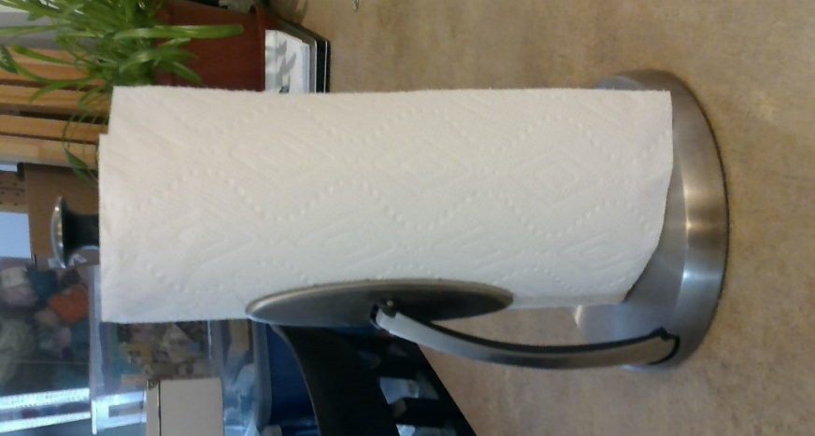

OXO PAPER TOWEL HOLDER $5
(Originally $27)
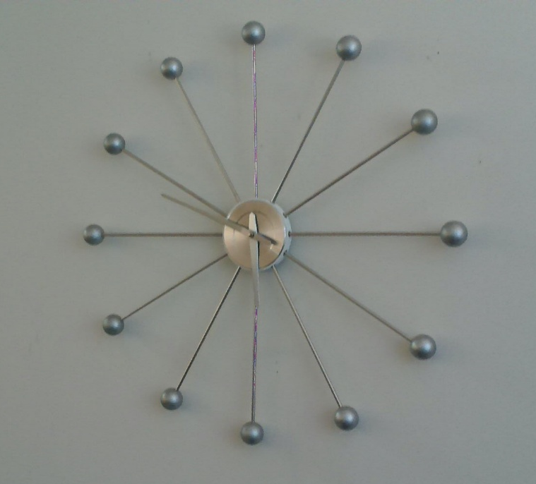

WALL CLOCK $10
(Originally $89)

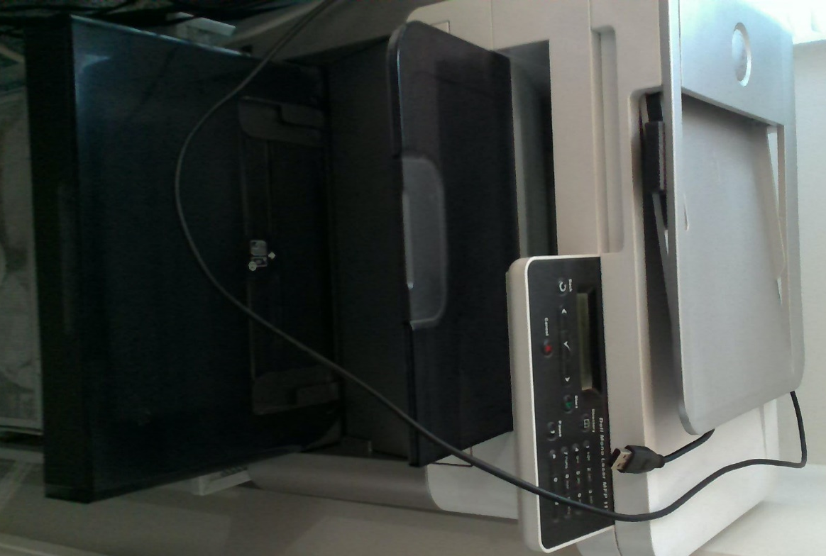

PRINTER $10
DELL Laser Printer 1125
Toner cartridge 35% full
Prints well;
Copies have a streak

