Mattress $50 (full size) & cover  :Bigger than twin  pending | 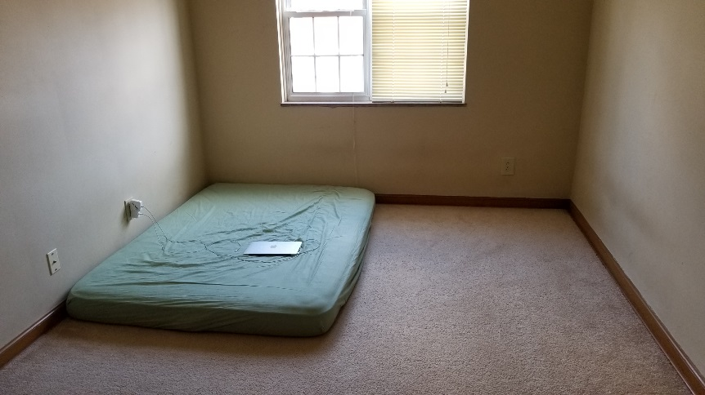
40’  Samsung smart TV $ 130  TV Stand (sliding door) $ 30  =  together150 | 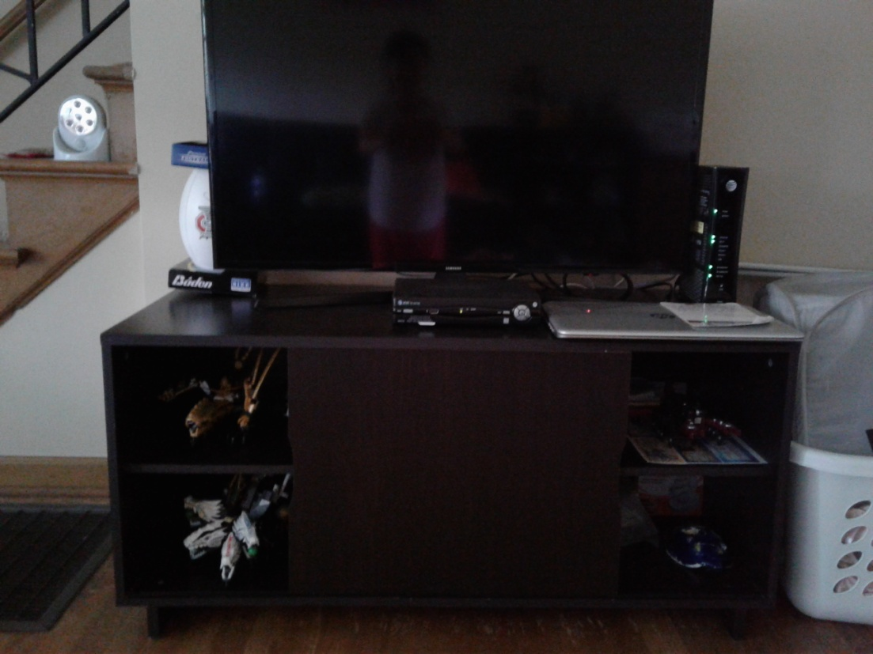
End table  (white) $10 | 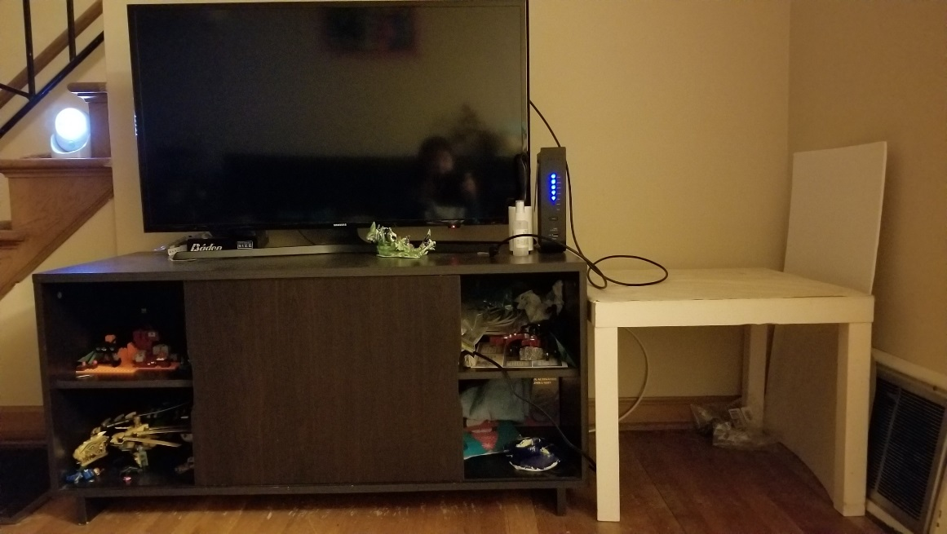
Christmas tree & crafts  $30 | 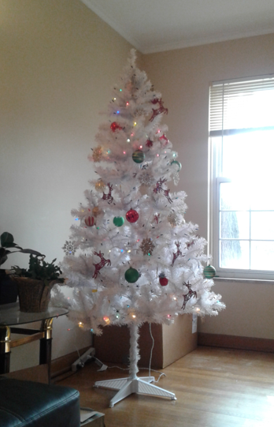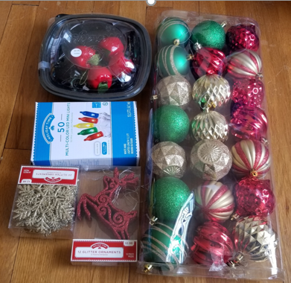
UltraSlimline 40" Oscillating Tower 4-Speed Fan with Remote, Black by Seville Classics  $30 | 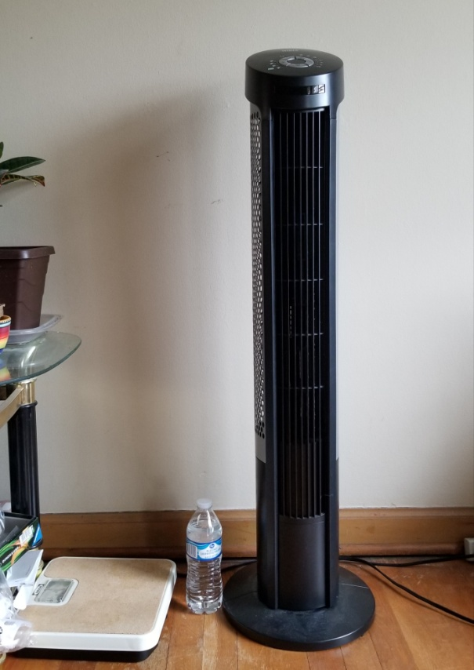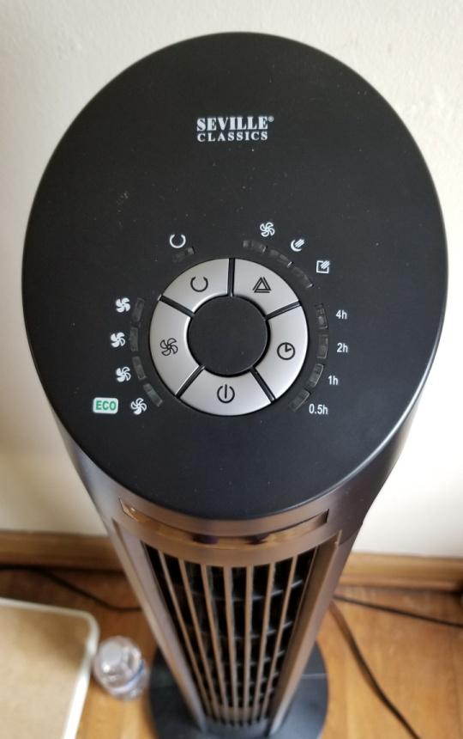  https://www.walmart.com/ip/UltraSlimline-40-Oscillating-Tower-4-Speed-Fan-with-Remote-Black-by-Seville-Classics/37342432?wmlspartner=wlpa&selectedSellerId=1812&adid=22222222227027137495&wl0=&wl1=g&wl2=c&wl3=43539187112&wl4=aud-534311367960:pla-83260637072&wl5=9014979&wl6=&wl7=&wl8=&wl9=pla&wl10=102975322&wl11=online&wl12=37342432&wl13=&veh=sem&gclid=CjwKCAjw7_rlBRBaEiwAc23rhlao1-Ucft4ktIOZLcBAhwwSMqugUBpnTS3RDVt-LESfxk-X5g5k2hoCIucQAvD_BwE
프린터 $25 | 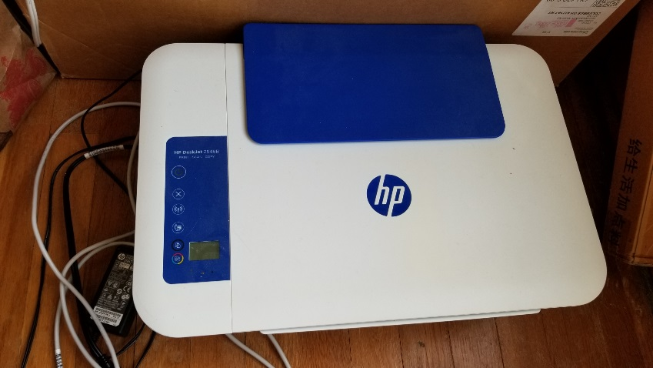
가습기  $5 | 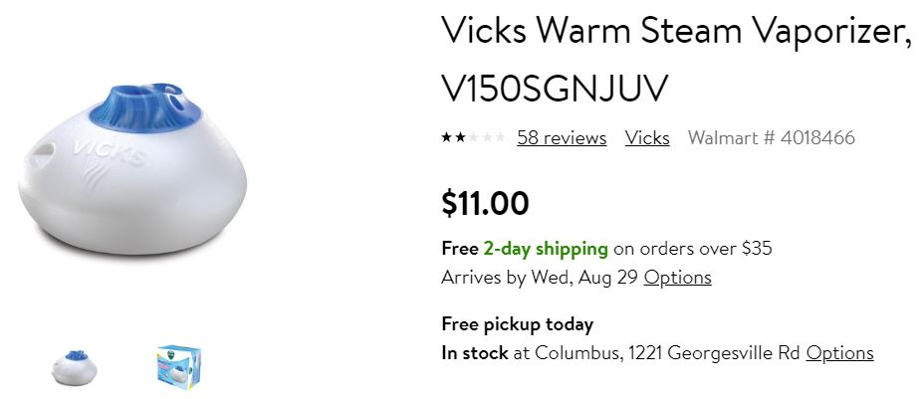
다리미 $15
SEPHORA (France)  Titanium Curling iron 1’  $40 | 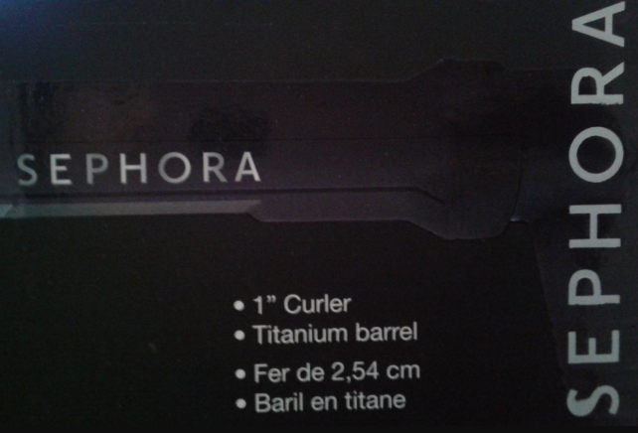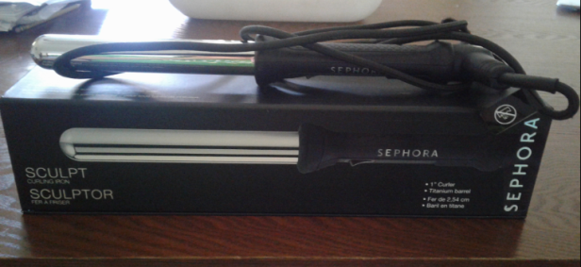
Holmes personal heater $10  Salton Portable cooktop $10 | 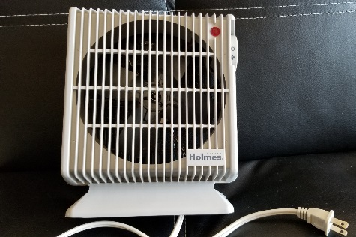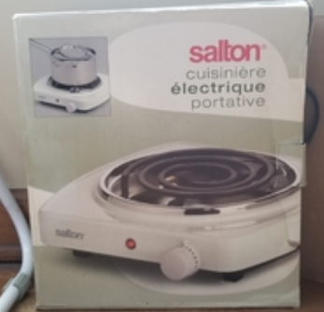
Electronic pot  $15거의새거  코팅 하나도 안 벗겨짐 | 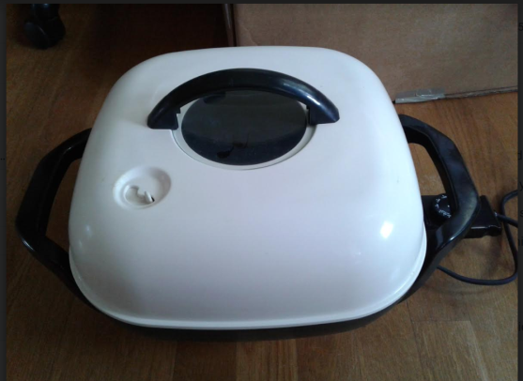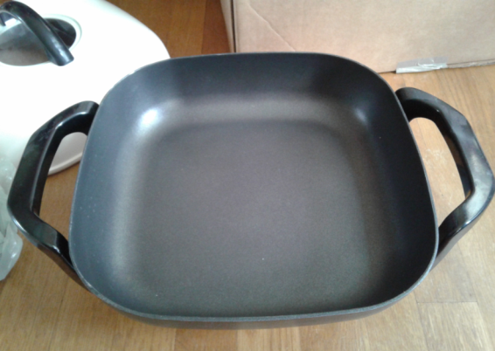
Ice cream bowl & salad bowl  for $5 | 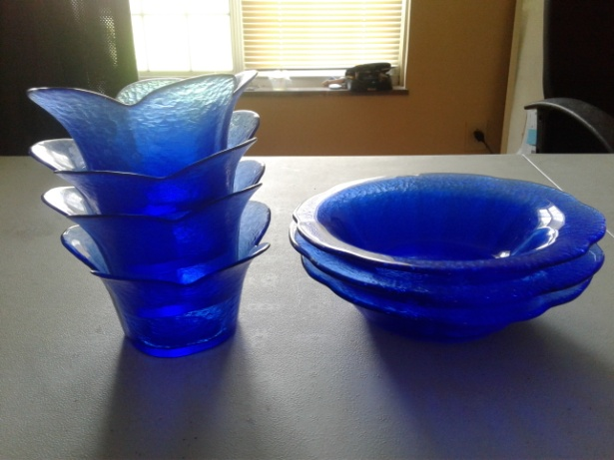
Rubbermaid1Galon/3.8L  텍, 비닐포장 안뜯은 새 것  $2 (구매가 $5)  $5 tag  붙어있어요 | 품 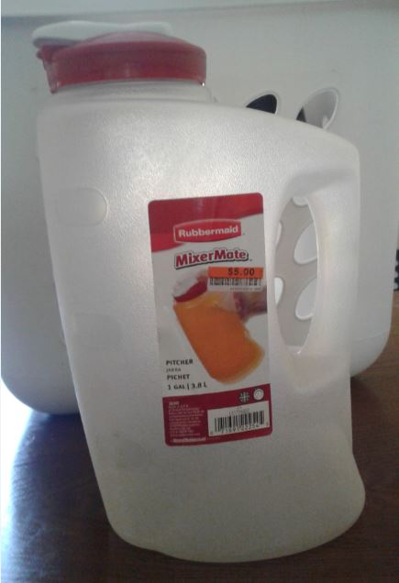
Drainer,  Steamer  $1/ each  Hanger  $1/8pcs | 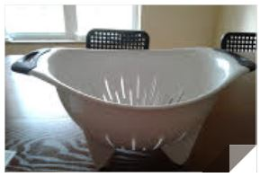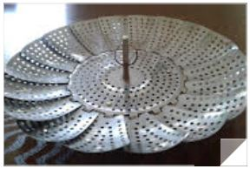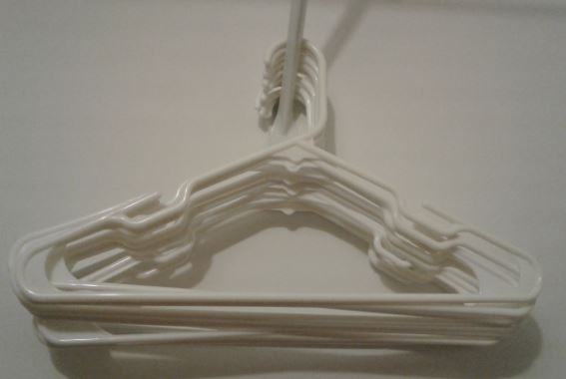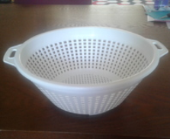
분리가능 거실등  (3단계 밝기조절/  전구 있음) $10 | 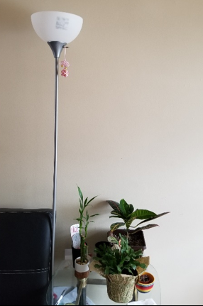
Food container

