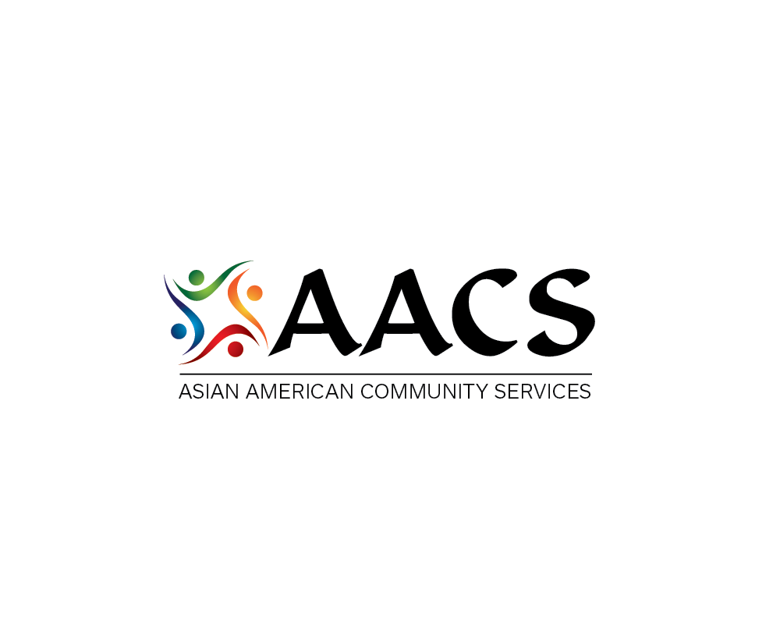
Open Enrollment Period :11/01/15-01/31/16
Free Help signing Up For Health Coverage
Where: Asian American Community Services Office
4700 Reed Rd, Suite B, Upper Arlington, OH 43220
When: Tuesday, Nov 17, 2015
Time: 6pm – 8pm
6pm-7pm: Individual/7pm-8pm: Small Business Health
Options Program

Affordable Care Act
Work Shop of Obama care Open enrollment
If you need more information, please contact:

Chin-Yin Shih 614-220-4023x224 or cshih@aacsohio.org (Chinese&English)
Asafu Suzuki 614-220-4023x240 or asuzuki@aacsohio.org (Japanese&English)
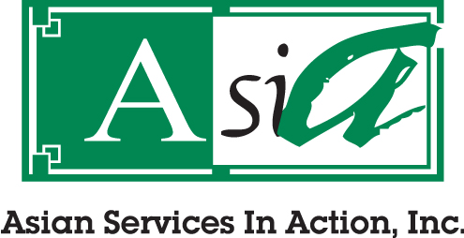
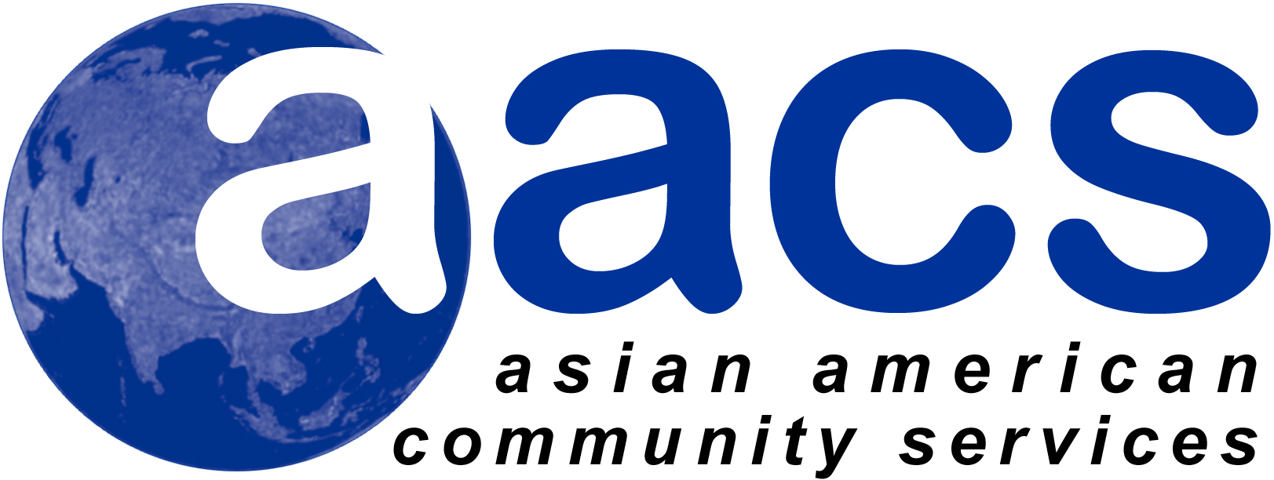
The project described was supported by Funding Opportunity Number CA-NAV-13-001 from the U.S. Department of Health
and Human Services, Centers for Medicare & Medicaid Services. The contents provided are solely the responsibility of the
authors and do not necessarily represent the official views of HHS or any of its agencies.

