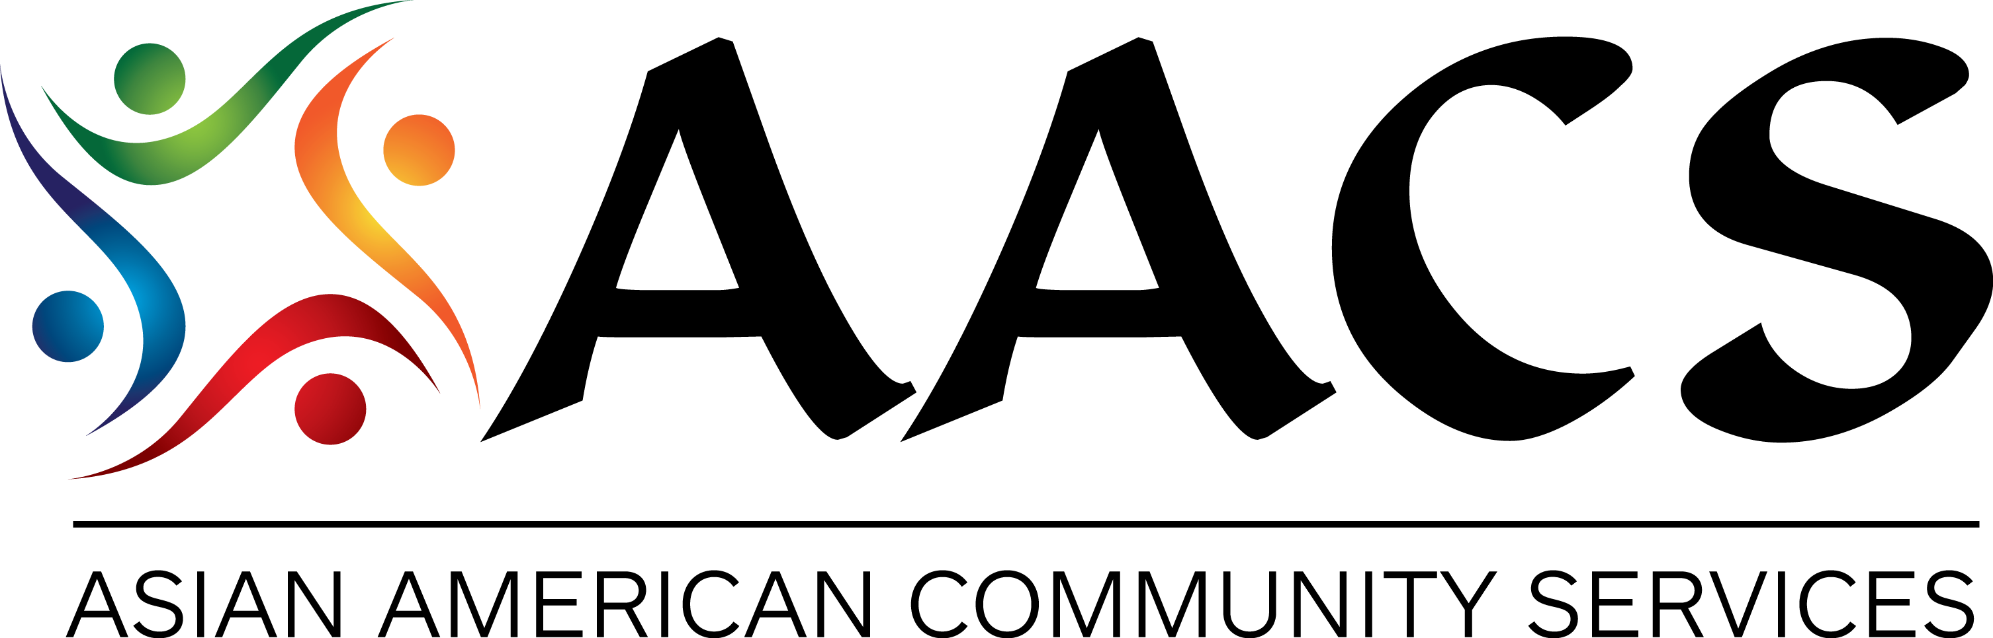
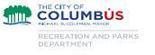
EnglishCanBeFun

Help immigrants get ready to learn:
⎜Reading ⎜Writing
⎜Listening ⎜Speaking

Five different levels:

Basic, low-Intermediate, Intermediate, High-Intermediate & Advanced

When: January 05 2015 – March 20 2015
Monday, Tuesday, Wednesday, Thursday, & Friday (10am-12pm) (Registration Fee: $25/class)

Where: 4700 Reed Rd. Suite B, Upper Arlington OH

Contact us to register or more information
Pyowook Han (phan@aacsohio.org or 614-220-4023 ext 227)
phan@aacsohio.org | 614-220-4023 x 227 | phan@aacsohio.org | 614-220-4023 x 227 | eswick@aacsohio.org | 614-220-4023 x 226 | eswick@aacsohio.org | 614-220-4023 x 226

