Moving sale

1. drawing ezel ($15)

2. plastic storage box ($ 5)

3. storage box * 3 ( $ 5 each)

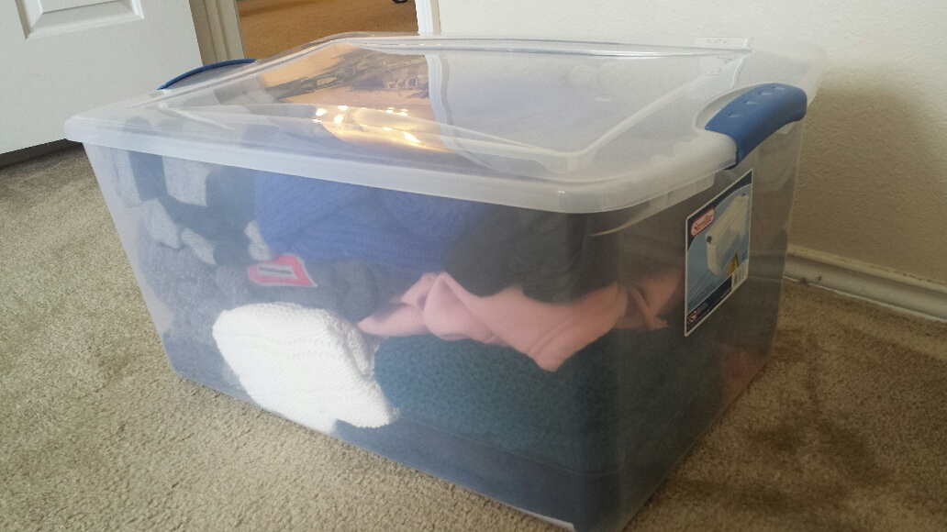

4. storage box ($10)

