Moving sale list
<장난감 및 육아용품>
- 쇼핑카트(Little tikes) $3
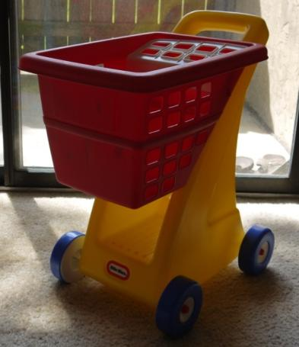
- Corn popper(Fisher price) $3
- 퍼즐 매트(Sassy) $3
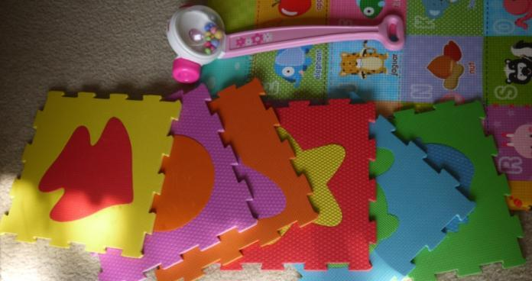
- 강아지 나무 퍼즐(Melissa&dough) $3
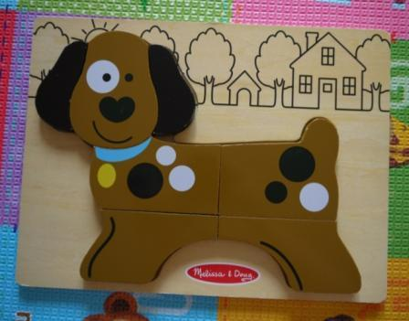
- Potty(Fisher price, pink) $5
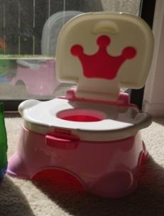
- 공 3개 (L, M,S) $3
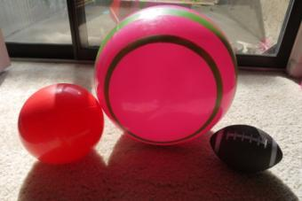
- Play yard $25
http://www.amazon.com/North-States-Superyard-Colorplay-Playard/dp/B006NTY1HU/ref=sr_1_2?s=baby-products&ie=UTF8&qid=1439985035&sr=1-2&keywords=play+yard
- Tricycle(Fisher price Dora explorer) $15
http://www.amazon.com/Fisher-Price-Dora-Explorer-Tough-Trike/dp/B0082J9FAC/ref=sr_1_2?s=toys-and-games&ie=UTF8&qid=1439985139&sr=1-2&keywords=dora+tricycle
- 키친셋트(Little tikes-like new) $35
http://www.amazon.com/Little-Tikes-Cook-Grow-Kitchen/dp/B008N6INE8/ref=sr_1_2?ie=UTF8&qid=1439928055&sr=8-2&keywords=little+tikes+kitchen+set
새 제품 구입하여 깨끗하게 사용했습니다. 소품포함입니다(amazon 제품 구성 참조).
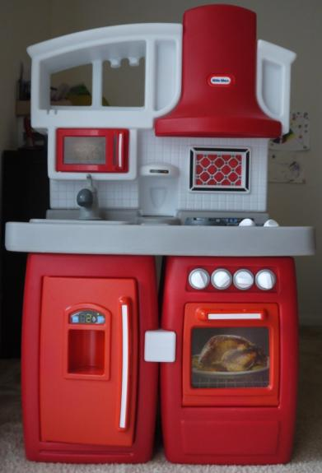

- 놀이방 매트(made in korea, Large size 210*140) $40
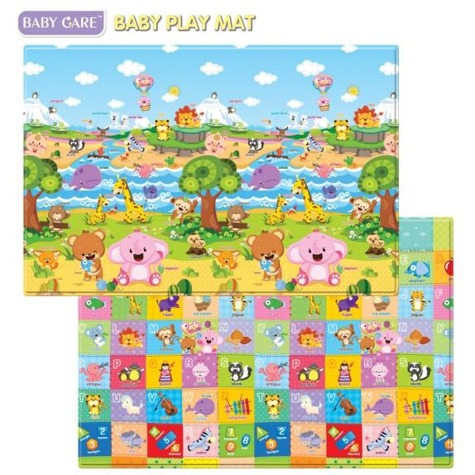
http://www.amazon.com/Baby-Care-Play-Mat-Friends/dp/B0058K5IIQ/ref=sr_1_1?ie=UTF8&qid=1439928210&sr=8-1&keywords=pingko+friends+playmat
- 나무 공구놀이(Melissa&doug tool kit) $5
- 알파벳 원목 퍼즐 $7
- Dora 인형의 집(2층집 도라 가족 및 다양한 효과음) $5
http://www.amazon.com/Fisher-Price-N0106-Doras-Talking-House/dp/B000VC6E7K/ref=sr_1_cc_1?s=aps&ie=UTF8&qid=1439985897&sr=1-1-catcorr&keywords=dora+house
- 버스(Wheels on the bus~노래 재생) $3
- 드럼(little tikes) $2
- 플라스틱 공구놀이(효과음) $3
- 수유쿠션(My breast friend, deluxe) $10
- Infant 머리 받침대(Carter’s) $3
- 체인징패드(Brica, like new) $5
- 젖병 건조대 $3

