Buck-I-Ride
U.V.-Airport Pick-up Service
$23.999
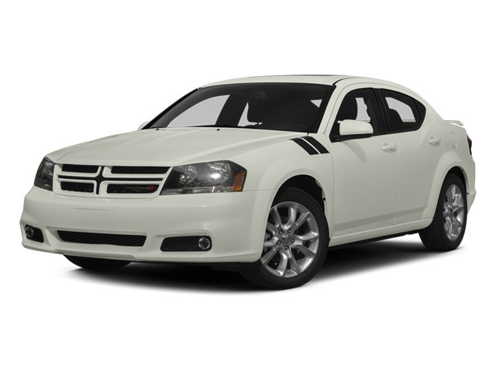
Experienced Professional Driver
To Schedule a ride, Call us on 614-432-8762
OSU Campus, AMC Theater, Sugar Bar pick-ups are also available

