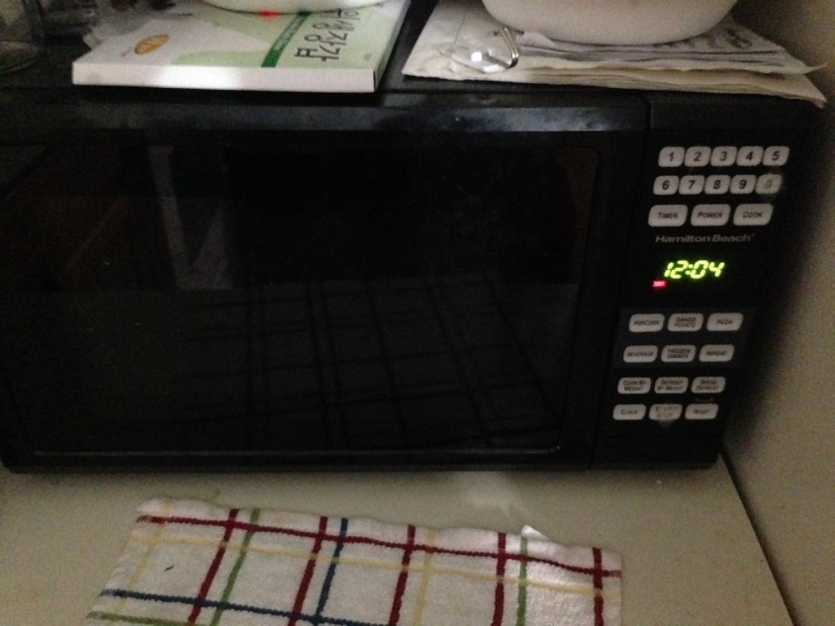
Hamilton Beach Microwave 700W : $15

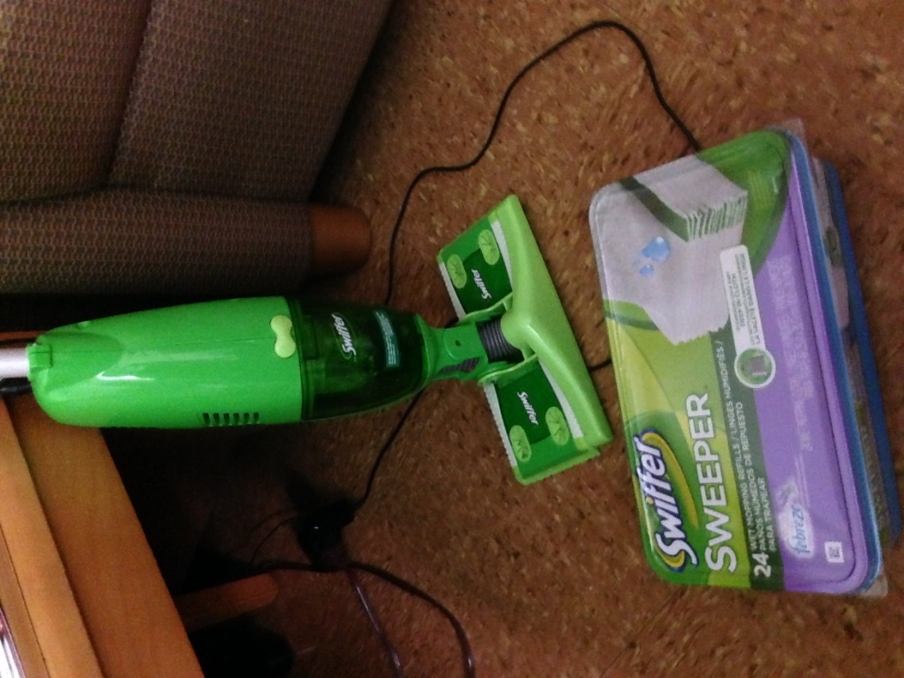
Swiffer SweeperVac + Wet Refill Febreze Lavender 24 count box (new): $20

